Reusing the same implant in multiple subjects.
  - Data recovery and workaround

Problem
If an implant is used with two or more subjects in the same experiment, only the data from the most recent subject will be readily available. Previous subjects will not appear as options to export or load into review.

Cause
After renaming a subject, the waveform data of further acquisitions will append to the .PNMWAV file created with the first subject’s name. While the .PNMWAV file keeps the earlier subject name, new Marks and Results files are created when acquisition begins with the new subject name.
Renaming a subject will also rewrite the .PNMEXP file. Only the subjects whose names are currently saved in the .PNMEXP file are available for export and/or review.

Fix
An update was included in the release of Ponemah 6.5 to address this problem. Renaming the subject in 6.5 will create a new .PNMWAV file for the new subject, separating the data.

Workaround Options

Prevention
When using an implant for more than one subject, create a new experiment for the second subject and use the new experiment for the acquisition. If the implant is used in more than two subjects, continue creating new experiments for each reimplantation.
Note: Ponemah can acquire from one experiment at a time. Therefore, create a second experiment only after all first-use subjects have completed their acquisitions – plan accordingly.

Recovery
To illustrate the recovery options, imagine the following scenario.
Implant A (serial number 1111) |  | Implant B (serial number 2222)
1st subject | Name: “Rat 1” | 1st subject | Name: “Mouse 1”
 | Start Date: Jan. 1 |  | Start Date: Jan. 1
2nd subject | Name: “Rat 2” | 2nd subject | Name: “Mouse 2”
 | Start Date: Feb. 1 |  | Start Date: Feb. 1

Note: To recover data from the first-use subject(s), you must know which subject names shared the same implant. In this example, you need to know that “Rat 1” and “Rat 2” were the subject names used on Implant A; “Mouse 1” and “Mouse 2” were the subject names used on Implant B.

Option 1
Open the experiment, and rename “Rat 2” as “Rat 1”. Save the experiment. Export directly from Ponemah, or Start Review and Save Derived Data.
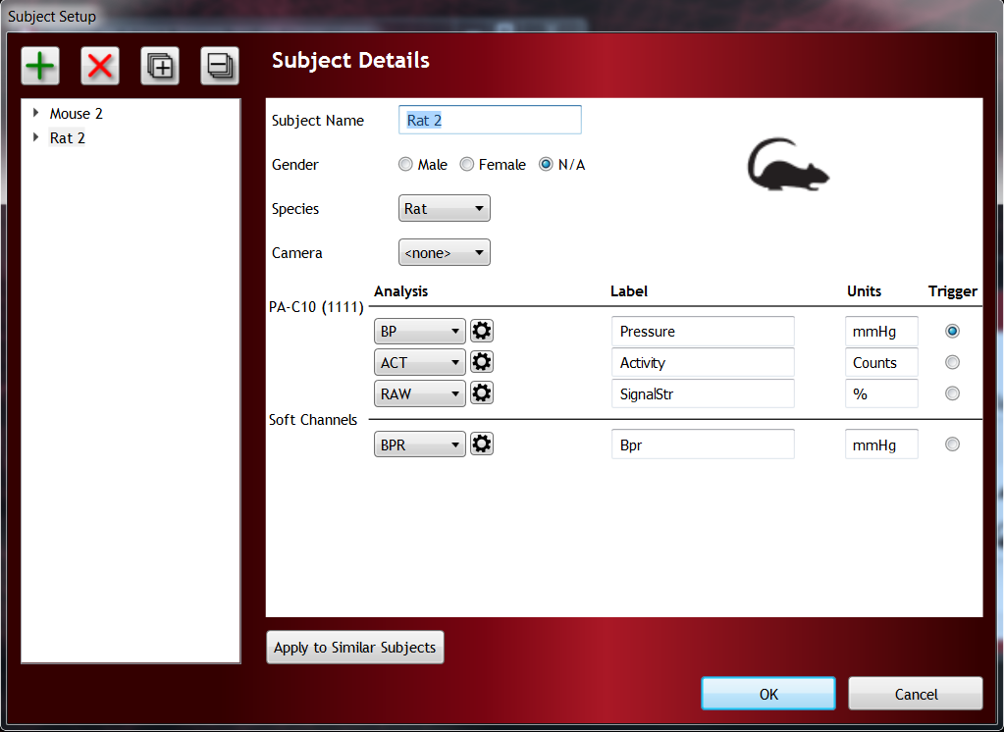
Note: Renaming “Mouse 2” as “Rat 1” will not successfully recover “Rat 1” data.
Note: The parameter data will include rows from throughout the acquisition on each implant. Rows corresponding with the subject currently named will contain data. Rows corresponding to the unnamed subject will not contain data.

Option 2
Create parser segments corresponding to the different subjects and based on the known datetime of explanation/reimplantation.
Reanalyze the entire channel to add marks to the full waveform.
Save Parsed Data.
Manually edit the resulting spreadsheet to show the appropriate subject on the worksheets.
Note: You must know the date and time when the implant was recycled from the first to the second subject.

