Transmitter = F40-EET
Receiver = RPC-1 S/N 020168
DL10 CH2
Dark Blue – input to divider(10Hz)
Light Blue – output of DL10
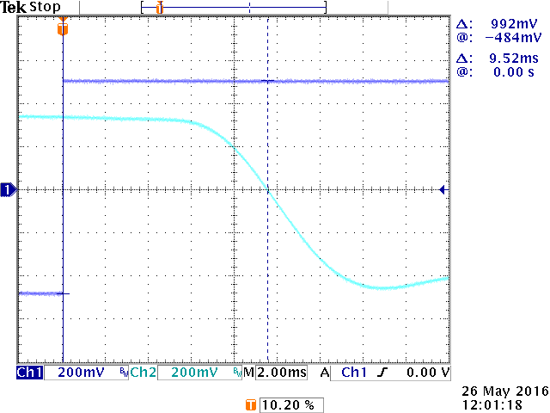
DL10 CH2
Dark Blue – input to divider(10Hz)
Light Blue – output of DL10
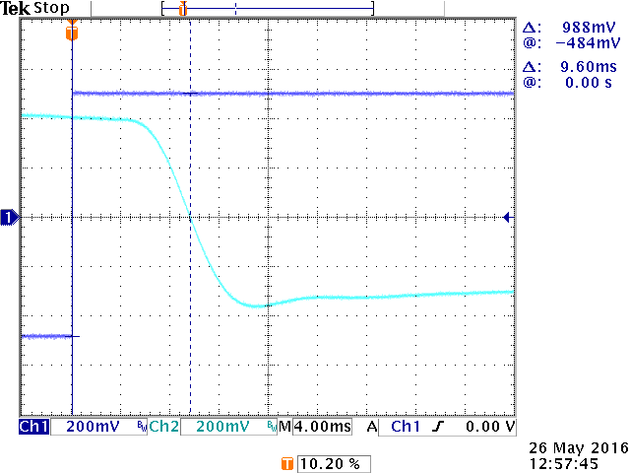

DL10 CH1
Dark Blue – input to divider (10Hz)
Light Blue – output of DL10

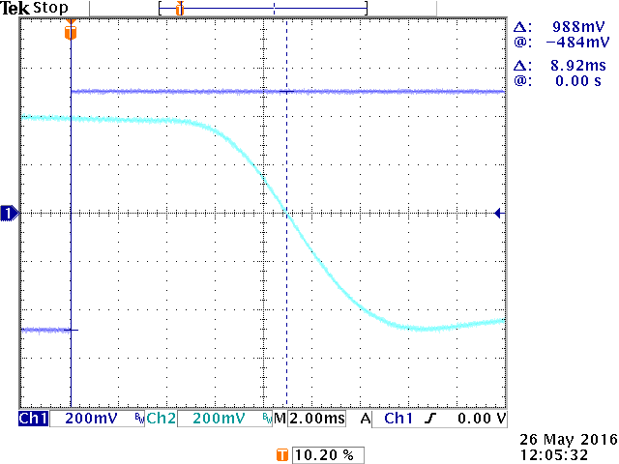
DL10 CH1
Dark Blue – input to divider (10Hz)
Light Blue – output of DL10

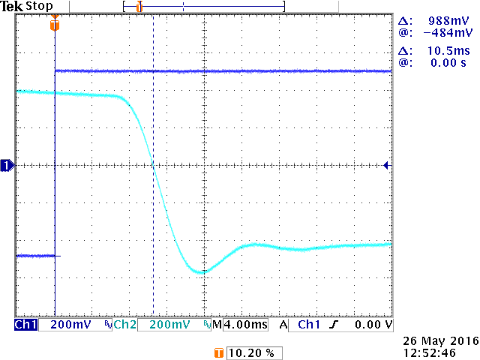
DL10 CH2
O-Scope envelope mode
Dark Blue – input to divider(10Hz)
Light Blue – output of DL10
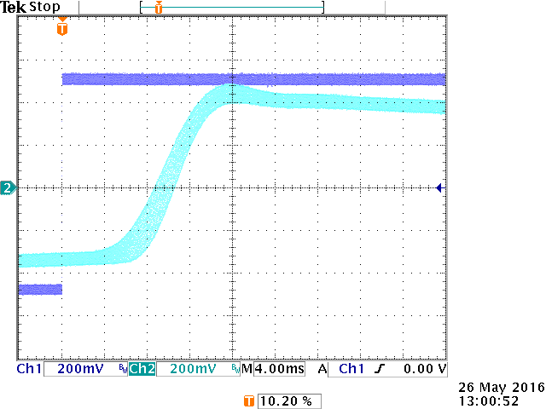
DL 10 CH1
O-Scope envelope mode
Dark Blue – input to divider(10Hz)
Light Blue – output of DL10
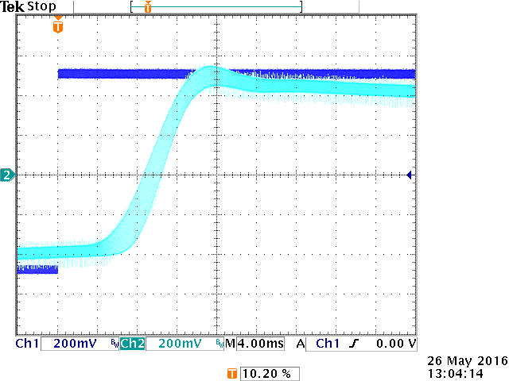
DL10 CH2
Dark Blue – input to divider(20Hz)
Light Blue – output of DL10
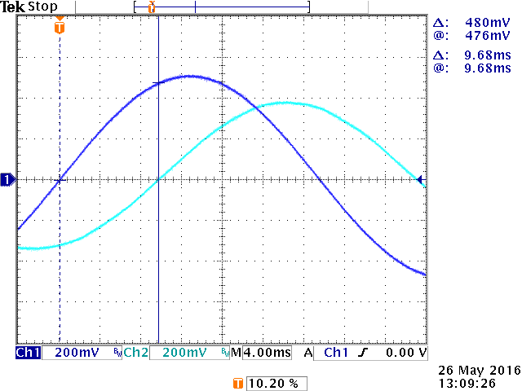
DL10 CH1
Dark Blue – input to divider(20Hz)
Light Blue – output of DL10
