Installation Instructions

The Measurement Computing PCI board CTR05, which provides time synchronization between DSI’s PhysioTel and PhysioTel HD implants and analog signals, has been discontinued by the manufacturer and is no longer available. In response, DSI has sourced a new board, the Quad04, to continue supporting applications where time synchronization between these acquisition interfaces is paramount. This new board required some modifications to the ACQ-7700/-16 Time Sync Service to support the new board, as well as 64 bit installations.

Compatibility:
This Service Pack offers support for the original CTR05 board and the new Quad04 board on 32 and 64 bit versions of Windows® 7 SP1. This service pack is only required under the following conditions:
- If a new board has been purchased after May 2013 for use with Ponemah v4.7+
- If upgrading the computer to a 64 bit operating system and to Ponemah v5.20

The ACQ7700/16 Time Sync software is now a separate install apart from the Ponemah install. The following steps reflect the installation and setup of the Data Synchronization Card Service Pack.

As of this writing, two Measurement Computing PCI boards are supported by Data Synchronization Card Service Pack. They are the PCI-CTR05 and the PCI-Quad04 boards. They are referred to below as “PCI Board”.

- If you have already installed a previous version of the Measurement Computing software, a PCI Board, and verified that they are working properly, you do not need to remove/replace the PCI Board; disregard steps 5-7 below. However, you must uninstall the current version of Measurement Computing software from your computer before installing the new software from the Data Synchronization Card Service Pack CD.

- If you do not have a previous version of the Measurement Computing software installed, please follow all of the steps below in order. Please make sure that you do not install the PCI Board until after the Measurement Computing Software is installed from the Data Synchronization Card Service Pack CD.

- Place CD into drive and close. The install should start automatically. If not, use Windows Explorer to run Install.exe.
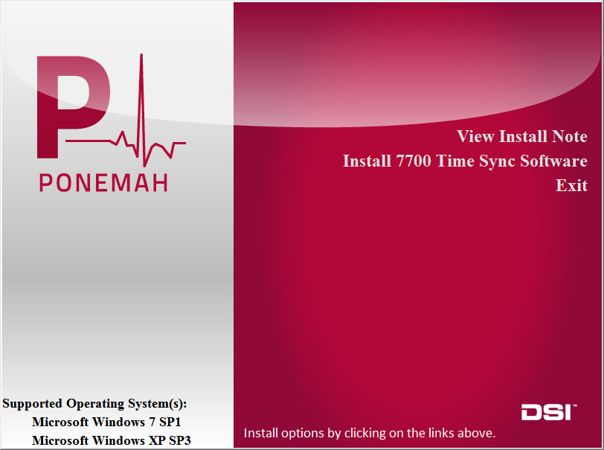

- Click on “Install 7700 Time Sync Software”. As shown below, a DSI service will be installed followed by the Measurement Computing libraries.

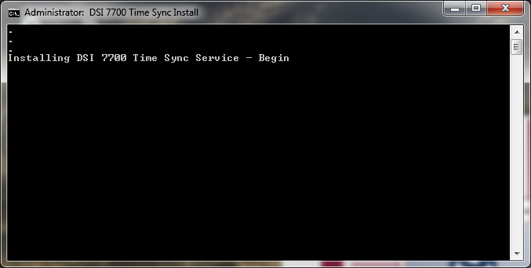

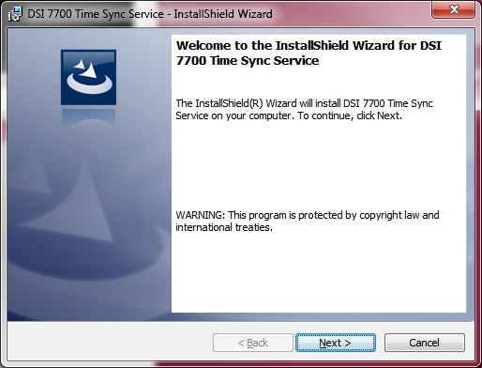

- Move forward through the install using the default values.

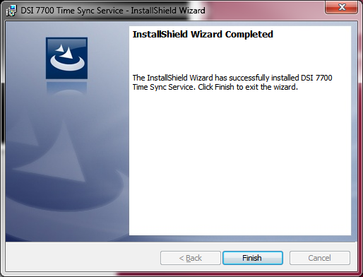

- Click Finish and the Measurement Computing Install will start. Move forward through the install using the default values. When finished a restart will be requested.

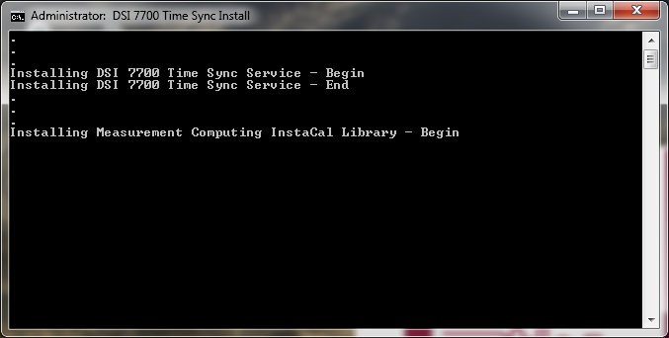

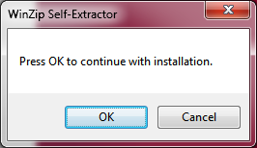

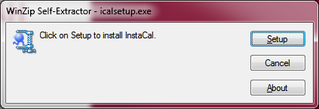

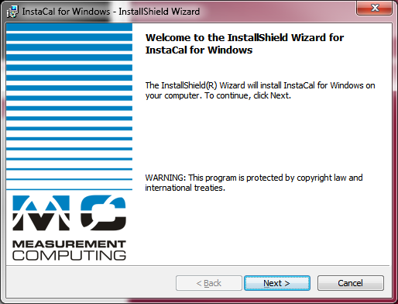

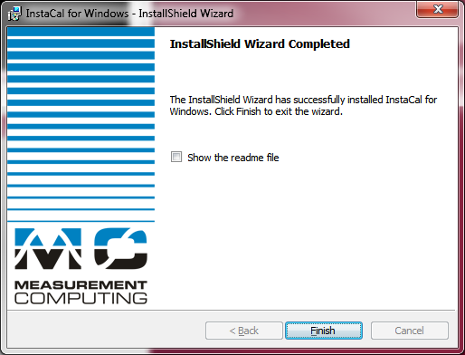

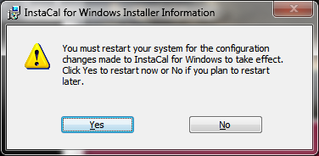

- Once the PC has been restarted and Windows completes its new configurations, the PC will have to be shut down again for the installation of the hardware.

- Remove the Power Cord from the back of the PC and then remove the service panel.

- Install the PCI Board and the DSI CQ2240 Data Acquisition card (if the DSI card was not previously installed) into the available PCI slots of the PC.

- Reinstall the service panel and power cord. Turn on the PC.

- Once Windows has completed its initial start up, it will then detect the PCI Board and it may ask to automatically install the available driver. Select No if Windows asks to connect to the Internet to search for available drivers. Select Yes when Windows asks to install automatically to complete the hardware and software installation.

- Assuming the Ponemah software is already installed, the DSI CQ2240 Data Acquisition card should be recognized by Windows and the available driver installed (if not installed previously).

- Run InstaCal from Start > All Programs > Measurement Computing > InstaCal. The screen should display the following if the PCI-Quad04 card is installed. The PCI-CTR05 board will be listed if it is installed.

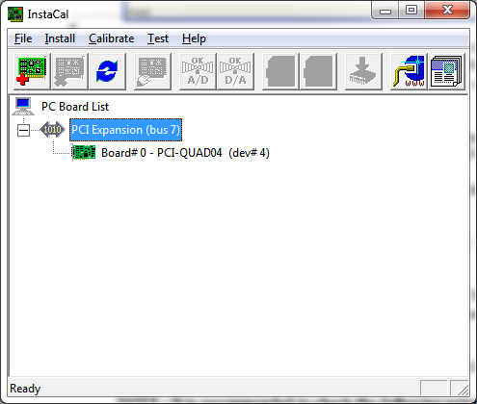

* It is important to note that if multiple Measurement Computing cards are installed, the PCI Board should be listed as Board #0 in the InstaCal window. If it is not, this can be done by right clicking on the PCI Board and selecting Change Board # from the list.

- Connect the time sync cable from the Measurement Computing PCI Board (on the back of the PC) to the Auxiliary port on the ACQ7700 USB or ACQ16 USB.

- Connect the Ethernet cable from the DSI Card (on the back of the PC) to the COM port on the DSI Matrix.

- Make sure all devices are installed properly and powered. Start the Ponemah application.

- Select Application Configuration from Options menu. Select the appropriate interface, ACQ16 USB-OpenART or ACQ7700 USB-OpenART, from the Acquisition Interface dialog.

- Restart Ponemah and select (or create) the proper protocol for acquisition.

NOTE: It is recommended to check the following prior to running the program to ensure correct installation.

  - Right click on My Computer and select Manage. Expand the Services and Applications selection. Locate DSI 7700 Time Sync and verify that the service is Started and set to Automatic.

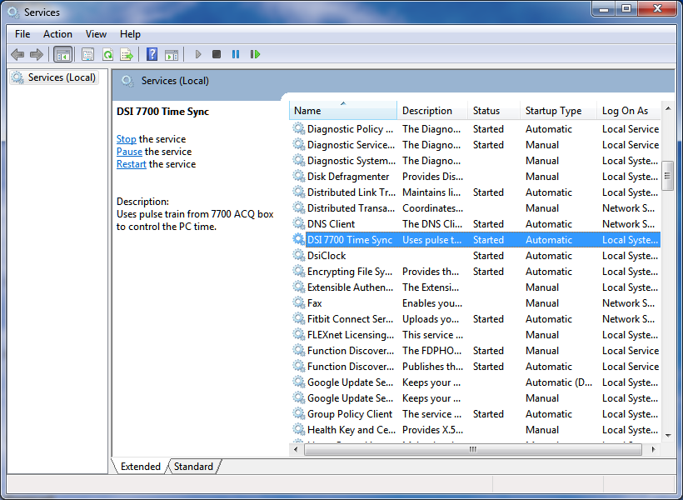

  - Also right click on My Computer and select Manage. Expand the Event Viewer / Applications and Services Log selection. Locate dsiTimeSync. The last log entries should indicate that the service has started and that the 7700 counter could not be read. Once the 7700 box is powered on the log should indicate that 7700 ticks have started.

  - If using the Dell Optiplex 745, the BIOS firmware needs to be at v2.4.1 or better. Similar considerations may need to be investigated if using other computers.

