TRX Firmware Install Instructions
Prior to installing, it is recommended to review the TRX Firmware Release Notes. The following are the instruction to install the firmware update.

Accessing TRX Firmware
The firmware file is typically provided on a CD from DSI. If the firmware was e-mailed by DSI, save the attached firmware file to a location on your hard drive. Make a note of this location for Step 8 below.

Installing TRX Firmware
- Launch Ponemah.
- Select the Hardware | PhysioTel Digital Telemetry Diagnostics…
Note: If using Ponemah v5.20, select Hardware | Diagnostics…
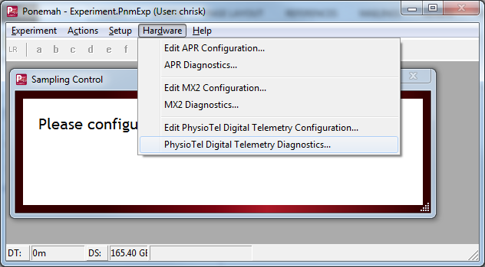
- Choose the CLC from the Name – Model Name (Serial Number) dropdown.
Note: Select the Refresh List button if the CLC does not appear in the dropdown list.
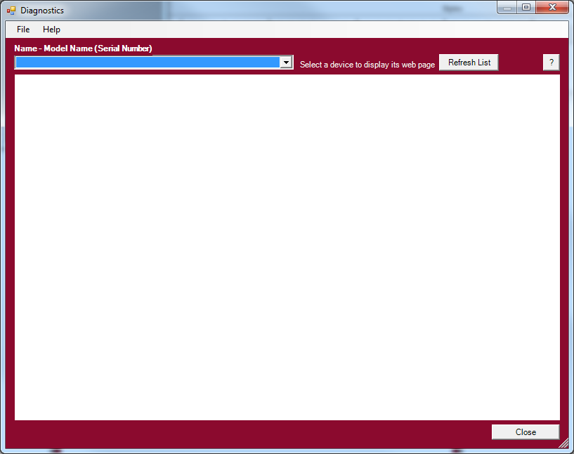
- Select the TRX Commands link from the list view on the left side of the diagnostic page.
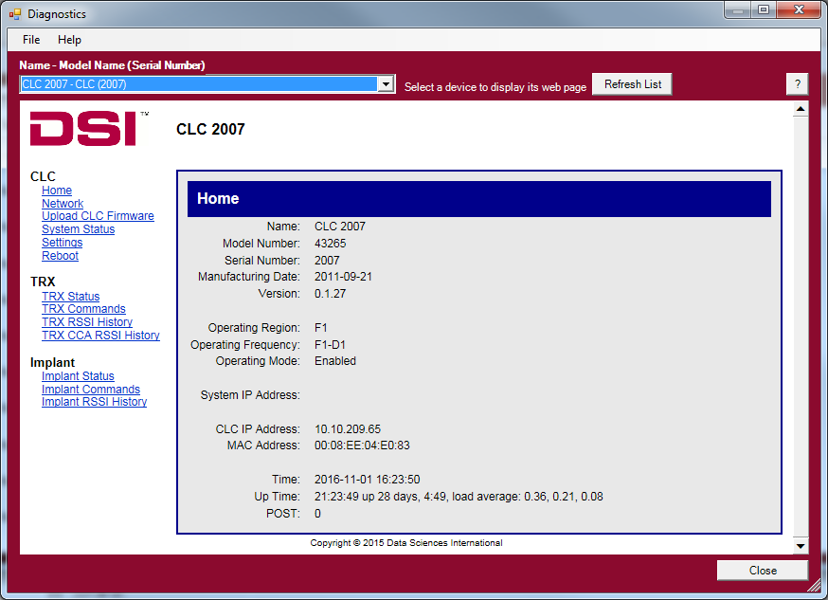
- Select the TRX number for the firmware update from the TRX No.
Note: The TRX number corresponds to the CLC jack that the TRX is connected to.
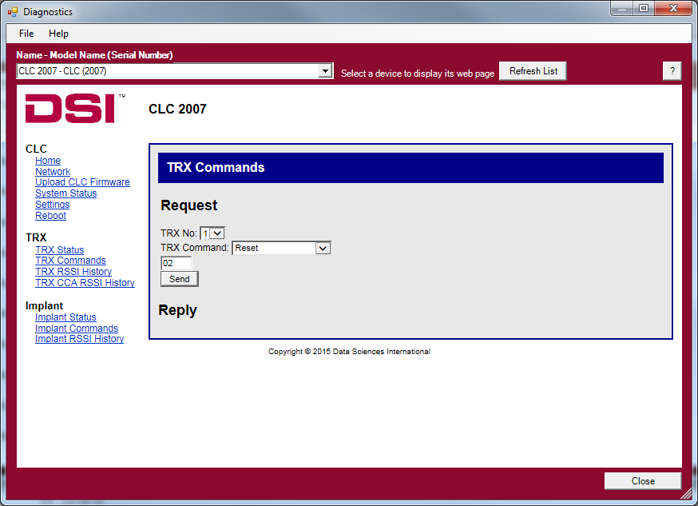
- Select Upload Firmware from the TRX Command dropdown.
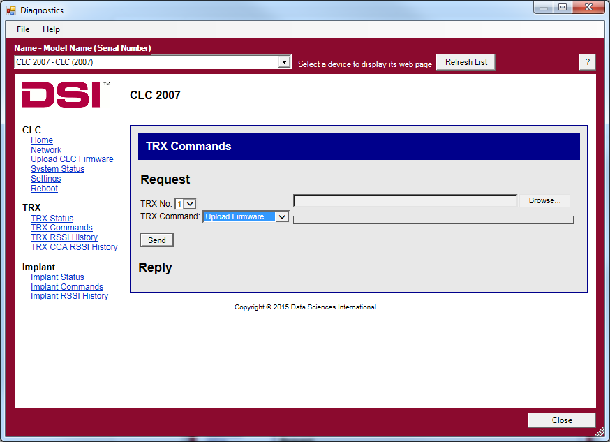
- Click the Browse button and navigate to the firmware file that was provided.
- Navigate to the file location for the TRX firmware, select it, and click OK.
- Click Send.
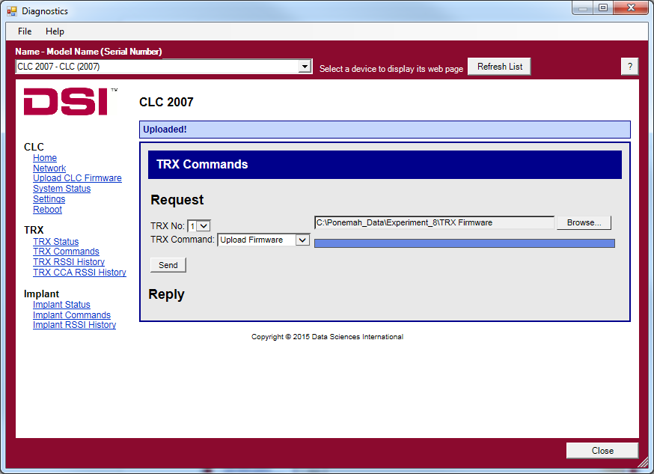
- After the firmware has been updated, verify the firmware revision by clicking on the TRX Status link from the left menu.

