Configuring a PhysioTel Digital Implant for BPR Analysis in Ponemah v5.20

The following steps explain how to enable a soft channel for a PhysioTelTM Digital implant in order for it to be used with Ponemah’s BPR analysis module to determine respiration from blood pressure.

1. With the CLC connected to the system, launch **Ponemah v5.20**.
2. Select **Hardware | Hardware | Edit Configuration…**

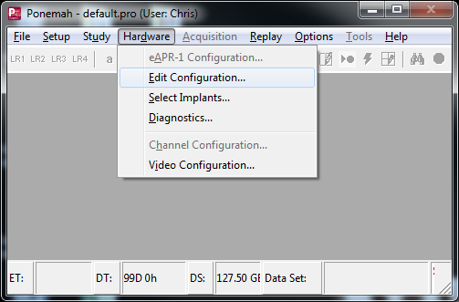

1. Configure the PhysioTel Digital implants using the *Configure Sources* wizard.
2. From the list view on the left, expand the implant of interest to display its channels.
3. Select **Signal Strength** from the list of channels.  
   *Note*: Signal Strength will be configured for use with BPR and will no longer be able to be used to collect the Signal Strength waveform.
4. Click the checkbox associated with **Enabled**.
5. Change the *Description* field to **RespPress**.

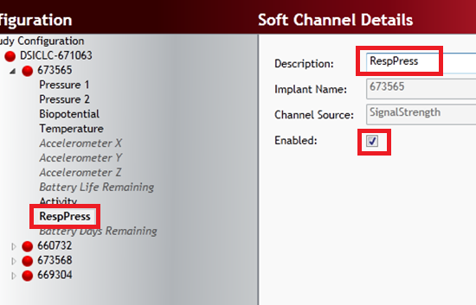

1. **Repeat** this process for each implant that will use the BPR analysis module.
2. Click **Save & Exit** when done.
3. Configure the protocol as normal.   
     
   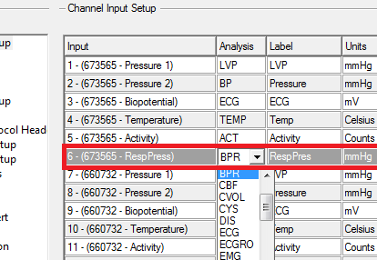  
     
   An extra channel should appear in Ponemah’s **Channel Input** **Setup** for each implant. Configure this channel to use the **BPR** analysis module, and configure the *Labels* and *Units* accordingly.  
     
   *Note:* If using **Auto Configure Protocol** function to automatically define protocol settings, Ponemah will setup the Respiration channel as **Signal Strength** using the **RAW** analysis module. Simply change the analysis module to **BPR**, then adjust the *Labels* and *Units* accordingly.