Configuring the Axis P1353 and Axis M1145-L IP cameras

Requirements:
- Axis PoE Midspan 1-Port – Supplied by DSI with new purchases.
- The camera’s IP address – Can be found by using the Axis Camera Management provided on the Axis install CD.
- Camera login information, username and password – Default is “root” for both.
- If using the Axis M1145-L please see the Note at the end of the Process section, as it requires a change to its settings.

Process:
To configure the Axis camera:
- Set up camera with the Axis PoE Midspan power source and plug into network switch.  Refer to the Axis PoE Midspan manual for complete instructions. This step is not required if your network switch has PoE capability. | 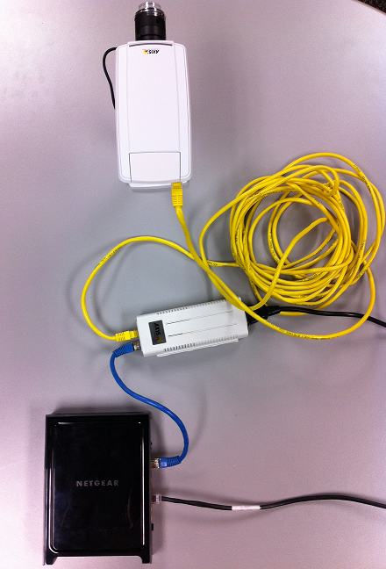  Axis PoE Midspan  Network Switch  Axis P1353 Network Camera
- Determine the camera of interest IP address. | 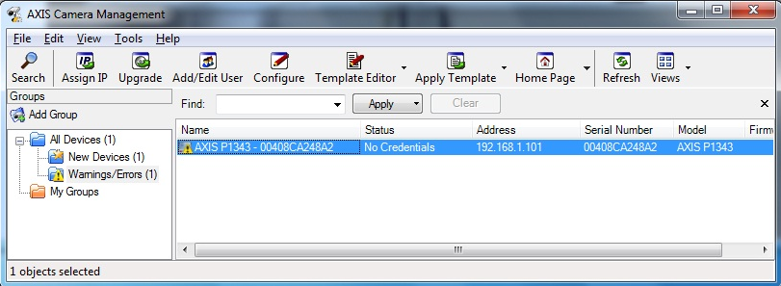
- Launch the camera setup wizard within the acquisition software and click add to add a camera. | 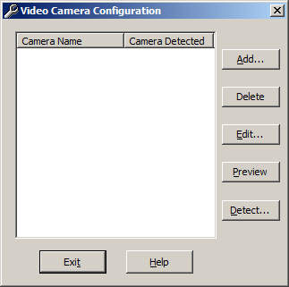
- Video Camera Settings  - Enter the desired camera name.  - Under Camera Type, choose “Axis Video Server” and “1.”  - Enable the Camera Log In and enter the username and password as displayed.  - Enter the camera’s IP address.  - Click “OK”. | 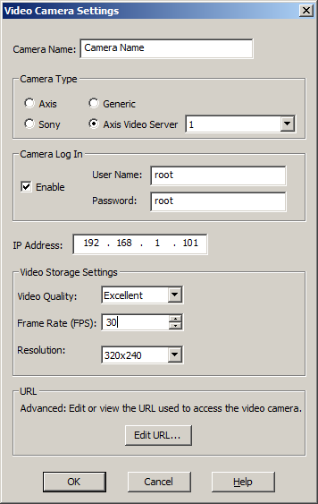
Note
The M1145-L requires a setting change within its settings.
- Select Start | Computer | Network
- Double-click camera
- Enter User name: root
- Enter Password: root
- Select Setup link
- Select Basic Setup | Users
- Under the HTTP/RSTP Password Setting section, change the Allow password type: to Unencrypted only.

