Adjusting the RSSI Threshold for a Transceiver (TRX) and an Implant
The RSSI Threshold for the PhysioTel Digital Implants and Transceivers (TRX) can be adjusted in the Communication Link Controller (CLC) Diagnostic page in Ponemah. Changes to the RSSI Threshold should only be made if advised by DSI. If DSI has recommended changes to the RSSI Threshold, these changes should be verified before starting an acquisition.

Adjusting the RSSI Threshold for a TRX
- With the CLC connected to the system, launch Ponemah.
- Select Hardware | PhysioTel Digital Diagnostics…
Note: If using Ponemah v5.20, select Hardware | Diagnostics…
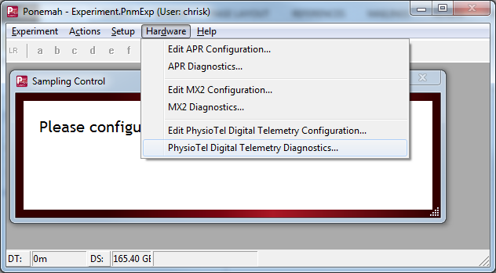
- Choose the CLC from the Name – Model Name (Serial Number) dropdown.
Note: Select the Refresh List button if the CLC does not appear in the dropdown list.
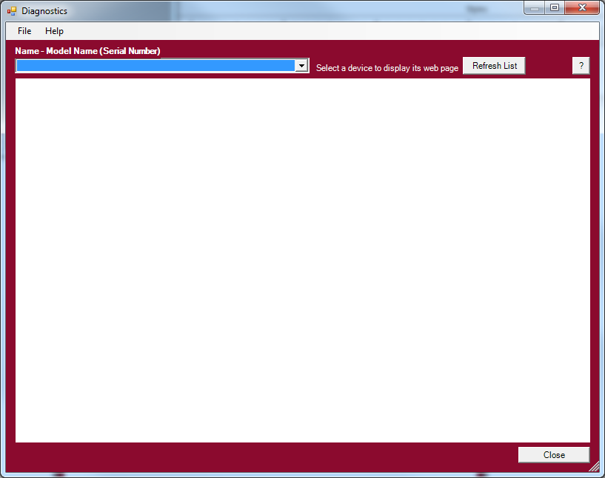
- Select the TRX Commands link from the list view on the left side of diagnostics page.
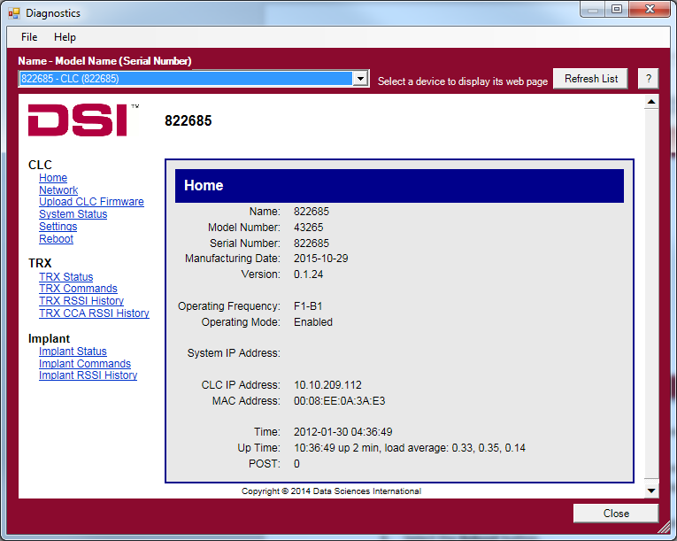
- Select the TRX number from the TRX No dropdown box.
Note: This number corresponds to the jack the TRX is plugged into on the back of the CLC.
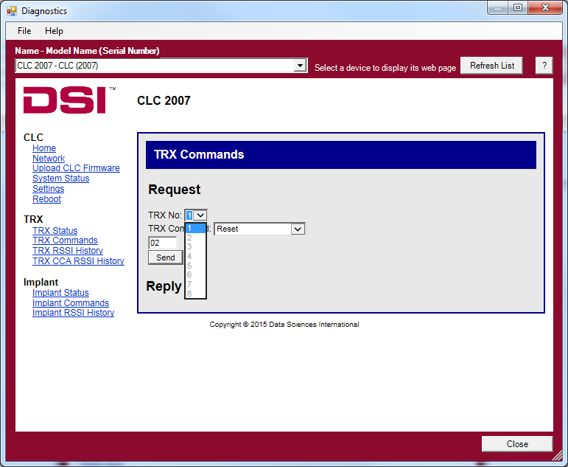
- Select Set RSSI Threshold from the TRX Command dropdown box.
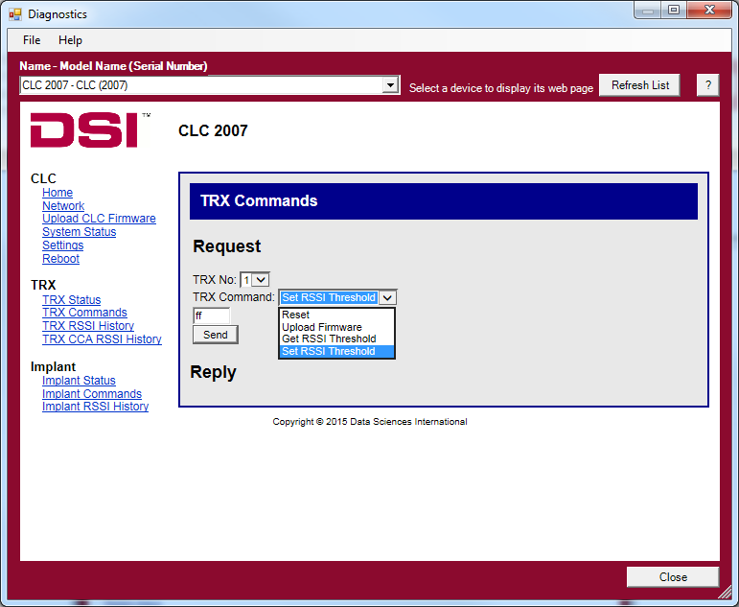
- A textbox should appear above the Send button that says “ff”.
- Replace “ff” with the desired RSSI Threshold value. This will typically be provided by DSI Technical Support.
- Select the Send button to set the RSSI Threshold.
- The diagnostics page will say “Command Completed” at the top when the change is made.
- Repeat this process for each TRX that is connected to the CLC.
Notes
- IMPORTANT: Changes made to the TRX RSSI Threshold will reset back to the default value when the CLC is rebooted or when a TRX is unplugged. The RSSI Threshold will need to be re-entered if this happens.
- If a TRX disconnects or behaves unexpectedly after setting an RSSI Threshold, reboot the CLC to reset the RSSI Threshold back to its default value.
- The TRX Status page will indicate the jack number of a TRX if it is not known.

Adjusting the RSSI Threshold for an Implant
- Repeat steps 1-3 above.
- Select the Implant Commands link from the list view on the left side of diagnostics page.
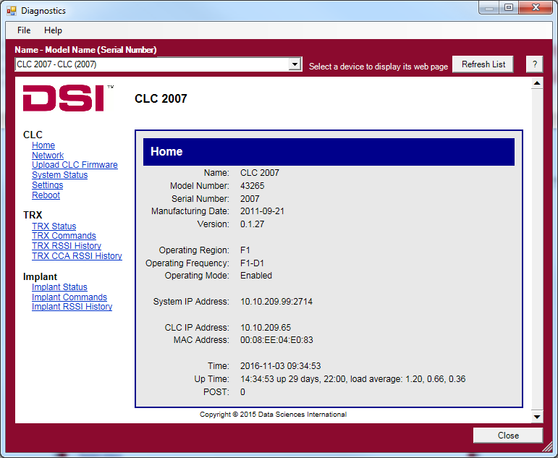
- Select the Implant ID from the Implant ID dropdown box.
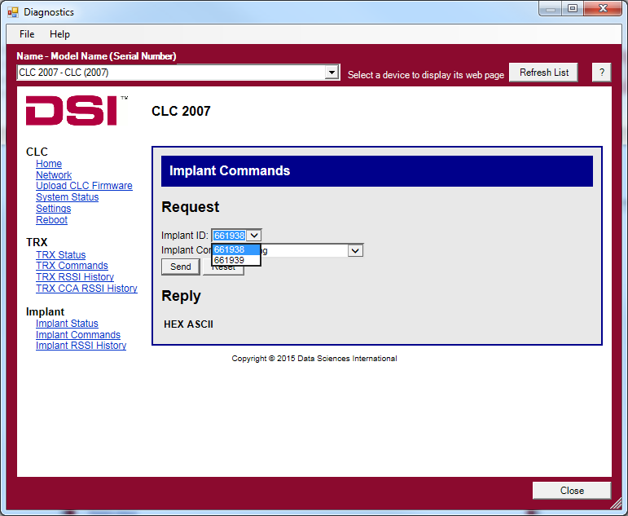
- Select Set RSSI Threshold from the Implant Command dropdown box.
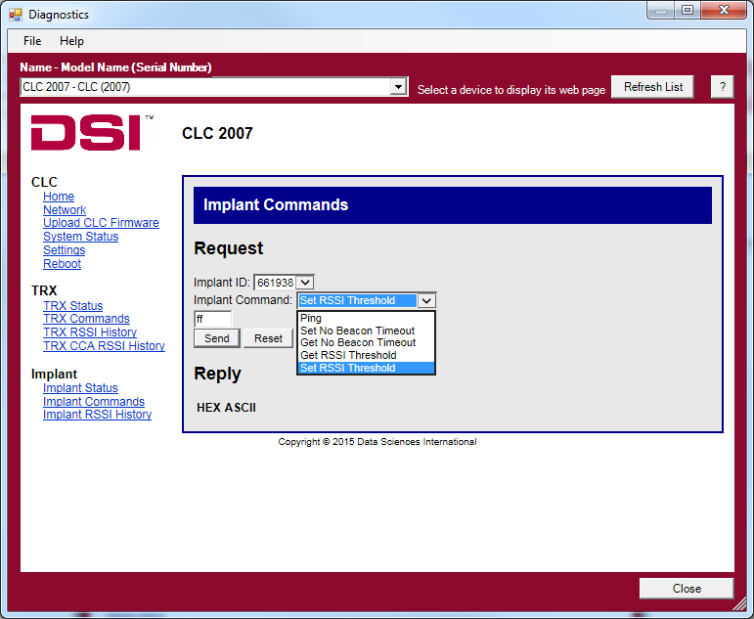
- A textbox should appear above the Send button that says “ff”.
- Replace ff with the desired RSSI Threshold value. This will typically be provided by DSI Technical Support.
- Select the Send button to set the RSSI Threshold.
- The diagnostics page will say “Command Completed” at the top when the change is made.
- Repeat this process for each Implant that is connected to the CLC.
Notes
- IMPORTANT: Changes made to the Implant RSSI Threshold will reset back to the default value when the Implant is turned off. The RSSI Threshold will need to be re-entered if this happens.
- If an Implant behaves unexpectedly after setting an RSSI Threshold, reset the Implant by turning it off and on again with a magnet. This will reset the RSSI Threshold.

