PhysioTel Digital RF Assessment Procedure Using Ponemah
The RSSI Threshold for the PhysioTel™ Digital Implants and Transceivers (TRX) can be adjusted in the Communication Link Controller (CLC) Diagnostic page in Ponemah. Changes to the RSSI Threshold should only be made if advised by DSI. The guide below explains how to perform a basic RF Assessment to determine the noise level in the room. This information should be provided to DSI Technical Support.

Performing an RF Assessment
Make sure the CLC is set to the frequency you want to scan and that TRXs are connected. Turn off any implants that are set to the same frequency you are checking.
- With the CLC connected to the system, launch Ponemah.
- Select Hardware | PhysioTel Digital Diagnostics…
Note: If using Ponemah v5.20, select Hardware | Diagnostics…
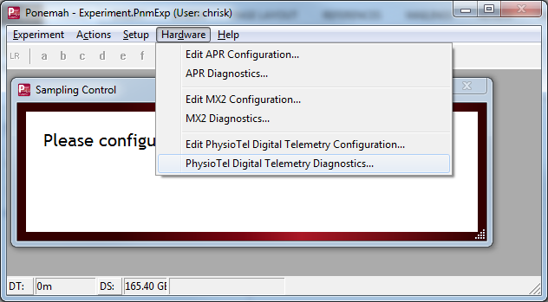
- Choose the CLC from the Name – Model Name (Serial Number) dropdown.
Note: Select the Refresh List button if the CLC does not appear in the dropdown list.
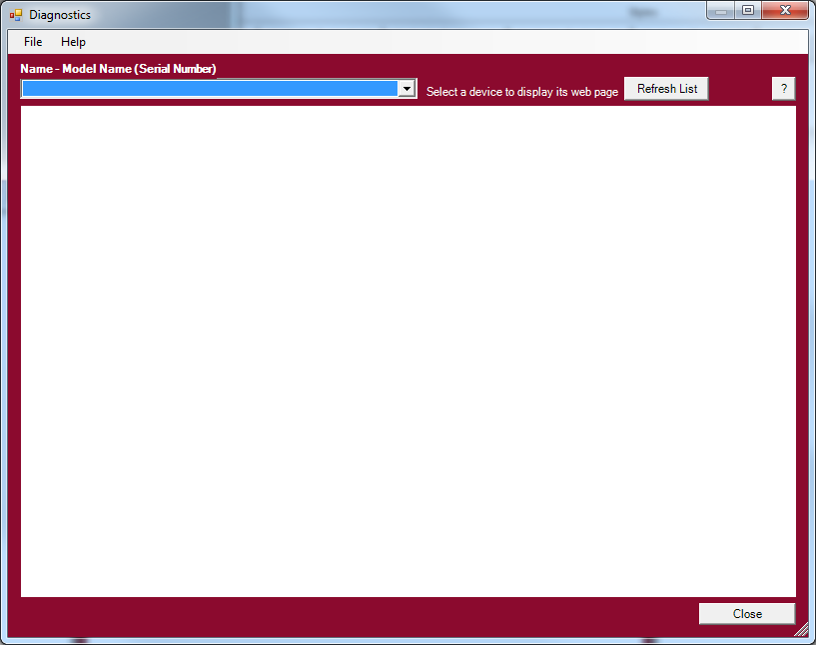
- Select the Settings link from the list view on the left side of diagnostics page.
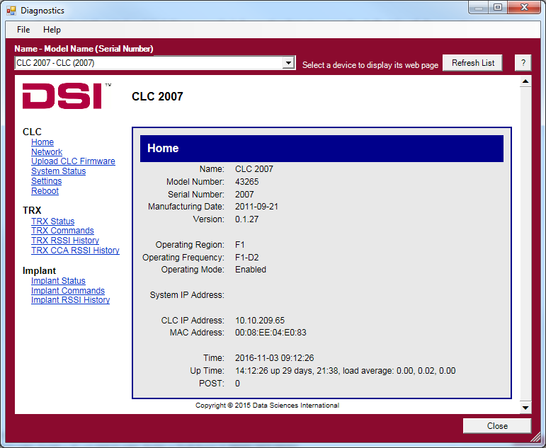
- Use the RFMode dropdown to select Assessment.
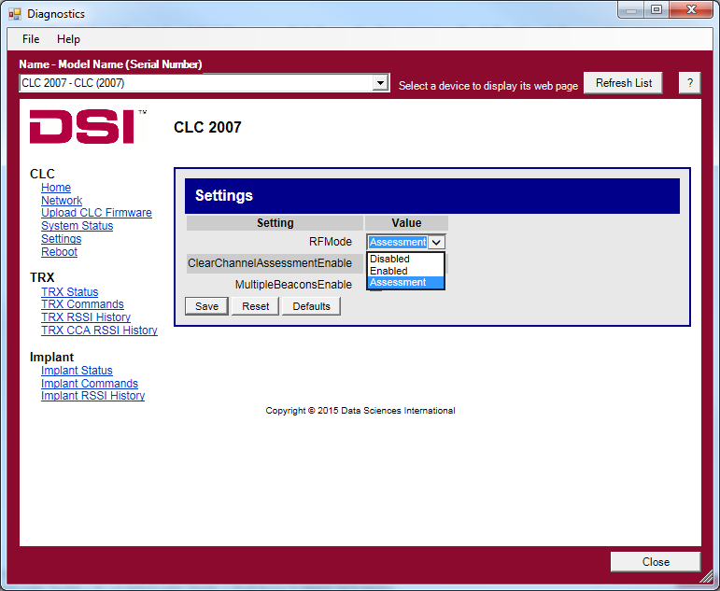
- Select the Save button.
- Select the TRX RSSI History link.
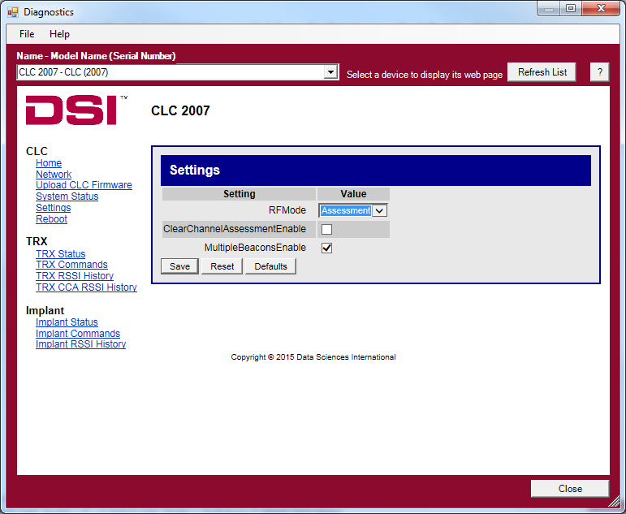
- At the top of the TRX RSSI History page, set Auto refresh page in… to 10 seconds.
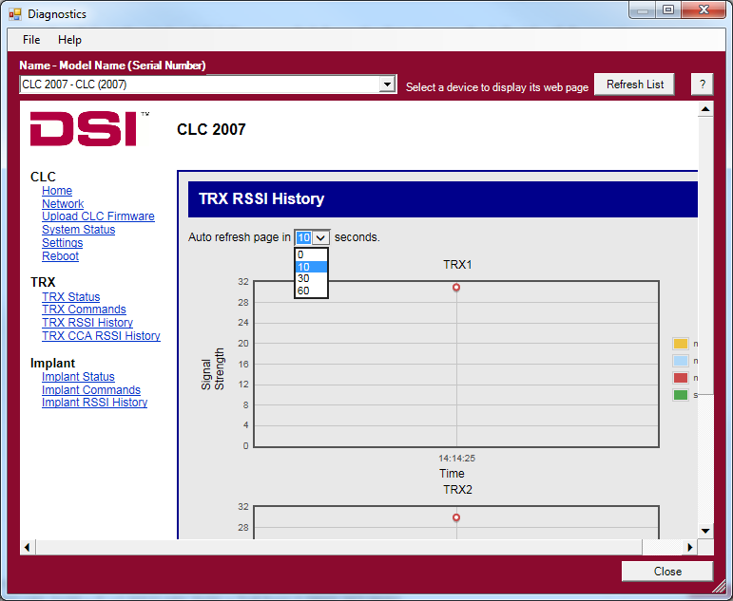
- Wait about 60 seconds for the graph below to populate with data related to your noise environment.
- Take a screenshot of the first graph on the page. Send the screenshot by e-mail to DSI Technical Support at support@datasci.com. They will evaluate the graph and send further instructions.
- Click the Settings link.
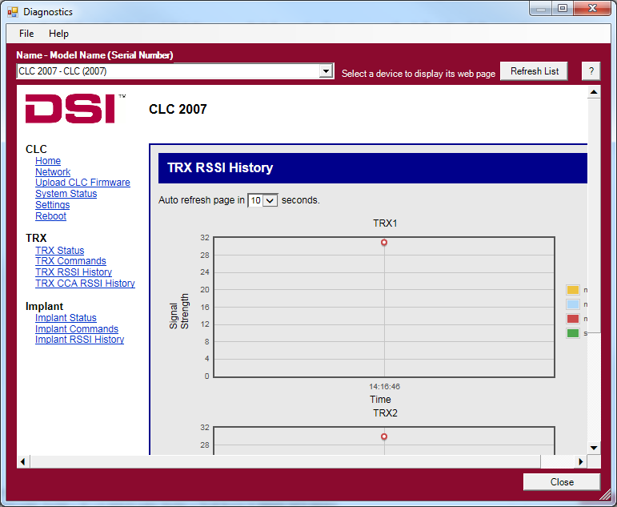
- Use the RFMode dropdown to select Enabled.
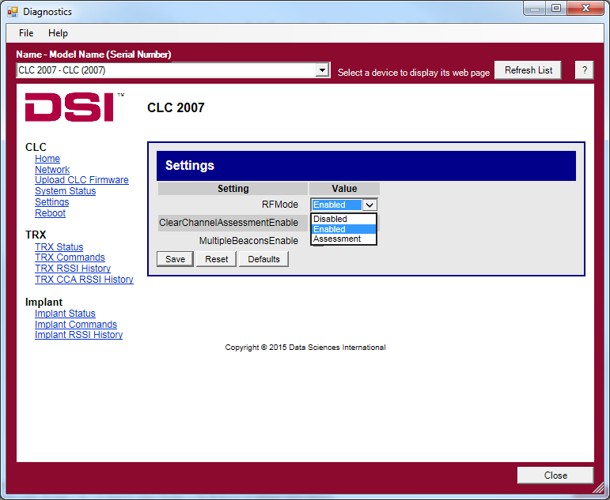
- Select Save.
TIP: A screenshot can easily be taken in Windows 7 using the ‘snip’ tool. Click the Windows ‘Start’ Button. Type snip and the snip program should appear at the top of the list. Using this tool, you can select your assessment graph with a box, and then save it to your hard drive.

Evaluating the Graph Yourself (not recommended)

- Examine the first graph on the TRX RSSI History page. Look at the line created by the red dots; this refers to the Mean Noise Floor in your room.
- Record the rough value of the Mean Noise Floor on the graph. In the example below, the Mean Noise Floor is about 9.
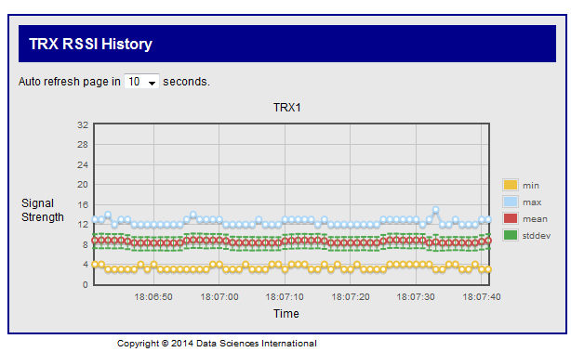
- Next, record the width of the standard deviation (green hashes). In the example above, the deviation is about 2 (1 level above the mean and 1 level below it).
- Calculate the necessary RSSI Threshold for the TRX and Implant as follows:
$$TRX RSSI Threshold=Mean Noise Floor+3*Std Dev$$
$$Implant RSSI Threshold=TRX RSSI Threshold-3$$
Example:
$$TRX RSSI Threshold=\left(9\right)+3*\left(2\right) \\ TRX RSSI Threshold=15$$ | $$Implant RSSI Threshold=15-3 \\ Implant RSSI Threshold=12$$
- Last, these values will need to be converted from decimal to hexadecimal. This can be done in Windows by using the calculator function. Open the Windows Calculator.
- In the calculator, click View | Programmer. Type in the TRX RSSI Threshold value from above.
- Click the bubble button next to Hex on the left side of the calculator. The number should change to the HEX equivalent. In the example above, 15 becomes F.
- Record this number or letter. If the calculator only gives a single digit or number, record a leading zero. In the example above, the output F should be written 0F instead.
- Refer to the technical note Adjusting the RSSI Threshold for a Transceiver (TRX) and an Implant for instructions on where to input the number.

