Finding Second Degree AV Block
Using Data Insights with ECG PRO Template Specific Attributes

Background
To locate and mark instances of Second Degree AV Block (isolated P waves), a new concept has been introduced in ECG PRO called Template Specific Attributes. Ponemah uses these attributes to mark an isolated P wave by shifting the marks from valid P wave to the isolated P wave. Data Insights can then be used to search for instances of abnormally large PR intervals to find isolated P waves.
This approach is needed as Ponemah will currently only mark one P wave per ECG cycle. When an isolated P is present in the signal, Ponemah is required to choose which P to mark. When using the attribute-based ECG analysis or ECG PRO analysis with standard settings, Ponemah will mark the P wave associated with QRS complex. Isolated P wave will be passed over since they are not directly associated with a valid ECG cycle.

Understanding Template Specific Attributes
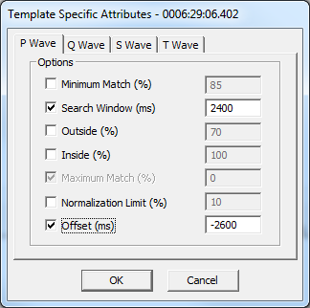
When locating instances of Second Degree AV Block (isolated P waves), normal P waves will need to be temporarily ignored. The P marks are instead placed on one of the isolated P waves without affecting the mark placement of surrounding cycles’ Q, R, S, and T waves. This is achieved using Template Specific Attributes to shift and extend the P match Search Region past the normal P wave to an area where the isolated P wave is expected to exist.
To do this, the P wave Search Window and Offset attributes within the Template Specific Attributes dialog need to be enabled. These are defaulted to appropriate durations for an initial search for isolated Ps, but may be augmented based on your data, if necessary.
Note: The Search Window and Offset attributes are species specific. Values displayed in the example screenshot (right) are for Dog and Monkey.

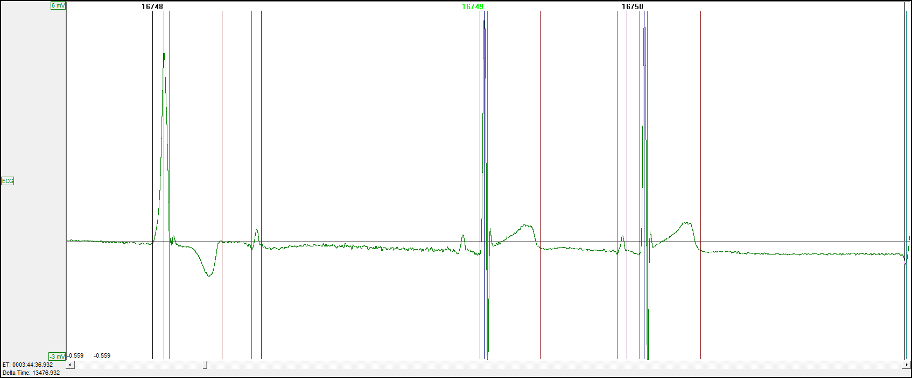
To better understand how Template Specific Attributes work, it is important to understand how the Search Window and Offset Template attributes work under normal conditions. The Search Window is the time range over which Template Analysis searches for the best match and is centered on the mark trying to be matched; e.g. P Start mark. The Offset attribute then shifts the Search Window center point by the time in milliseconds (ms) entered in the associated text field. The images below illustrates the typical ECG PRO Search Window case (A) and how these attributes are applied when updated for isolated P wave searches (B) visually.
A:
Default P wave Search Window for P start mark placement - 20 ms either side of P start mark.
Note: Search Windows are relative to the Template Cycle marks (not displayed), but since the P start is within the Search Window is it correctly matched.
Offset
(-2600 ms)
Extended
Search Window
(2400 ms)
200 ms gap to not mismark on normal P
2nd Degree AV Block
(Isolated P)
B:
...
...
...
...
In B, the Search Window extends past the data being displayed on the graph. The R wave of the previous cycle acts as a hard cutoff for the Search Window. This algorithm has additional logic built in to prevent ECG PRO from marking the T wave of the previous cycle as the isolated P wave.
Note: Template Specific Attributes are available for all Search Regions, however the current use case is for isolated P waves.

Process
ECG PRO’s Template Specific Attributes provide the user a mechanism to override the global/general ECG PRO Match attributes (Match % and Advanced Setup) for one or more of the Templates within the Template Library, while keeping the global/general Match attributes for the remaining Templates.
The process to find instances of Second Degree AV Block (isolated P waves) is:
- Run ECG Attribute based analysis with ECG analysis module
- Use ECG PRO to accurately mark the ECG cycles’ Q and S waves
(Optional: Required to identify Ventricular and Junctional beats)
- Use ECG PRO to accurately mark the ECG cycles’ P wave
- Save Marks Section
(Saving at this time will save the derived data and mark placement prior to shifting the P marks to the isolated P waves for a more accurate representation of the interval-base analysis. See Derived Output Impact section for more details.)
- Choose one or more of the Template Cycles used for P wave mark placement for use with Template Specific Attributes.
  - Template Cycles with the largest match percentage should be used.
  - Enable the Search Window and Offset attributes. DSI recommends starting with the default values.
- Execute ECG PRO, enabling only the P wave Match Region.
- Use Data Insights to find and report on instances of AV Block.

Derived Output Impact
Using ECG PRO Template Specific Attributes may impact your Derived Output. This is due to the shifting of the P wave marks from the ECG cycles associated P wave to the isolated P wave, as this will result in an abnormally large PR interval being calculated for that cycle. This will be averaged into the Log Line averages reported to the Derived Parameter and Data Reduction List Views (spreadsheets).
If only a few isolated P waves exist, then the large PR intervals will not have much of an effect on the derived parameters (based on species and logging rate). However, if a large number of these exist in the data set or are clustered together, the reported PR interval in the Derived Data and Data Reduction List Views will be misrepresented. It is recommended to Save a Mark Section prior to using ECG PRO to search and report on Second Degree AV Block. Once your Second Degree AV Block search is complete, the Template Specific Attributes can be disabled and P wave Match Template analysis can be re-run to return to a state where the normal P waves are marked and reported appropriately.

If you should have any questions, please contact DSI Technical Support.

