Installation Notes
CLC Firmware 0.1.27
Prior to installing, it is recommended to review the CLC Firmware 0.1.27 Release Notes. The following are the instruction to install the firmware update.

Accessing CLC Firmware
The website is the primary means for delivering firmware. If a CD is desired, one can be requested by contacting DSI Customer Service (CService@datasci.com).
- Navigate to www.datasci.com
- Browse to Resources | DSI Gateway Portal.
- Login using your User Name and Password. If you have forgotten or do not have a User Name and Password, the ability to request a new password or register at the site is available.
- Select Software Updates.
- Click the CLC 0.1.27.zip to download the contents to a desired location.
- Extract the files by right-clicking the .zip file and choosing Extract.

Installing CLC Firmware
- With the CLC connected to the system, launch Ponemah.
- Select Hardware | PhysioTel Digital Diagnostics…
Note: If using Ponemah v5.20, select Hardware | Diagnostics…
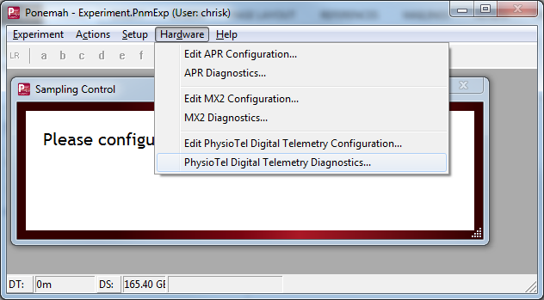
- Choose the CLC from the Name – Model Name (Serial Number) dropdown.
Note: Select the Refresh List button if the CLC does not appear in the dropdown list.
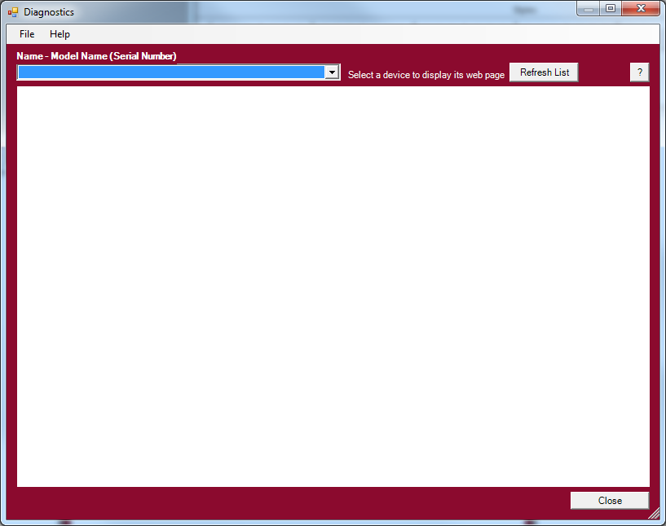
- Select the Upload CLC Firmware link from the list view on the left side of diagnostics page.
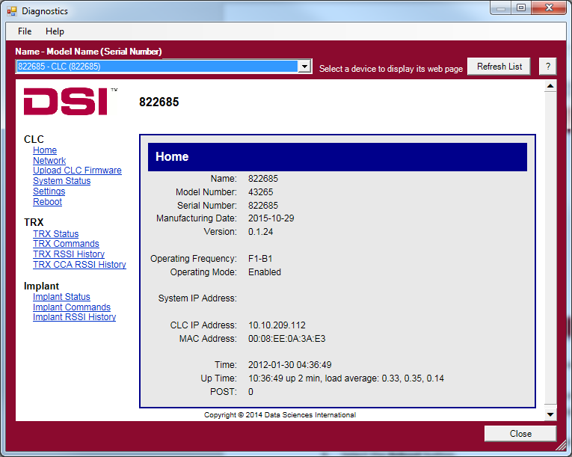
- Please complete steps a. – d. below twice.
  - Select the Browse… button.
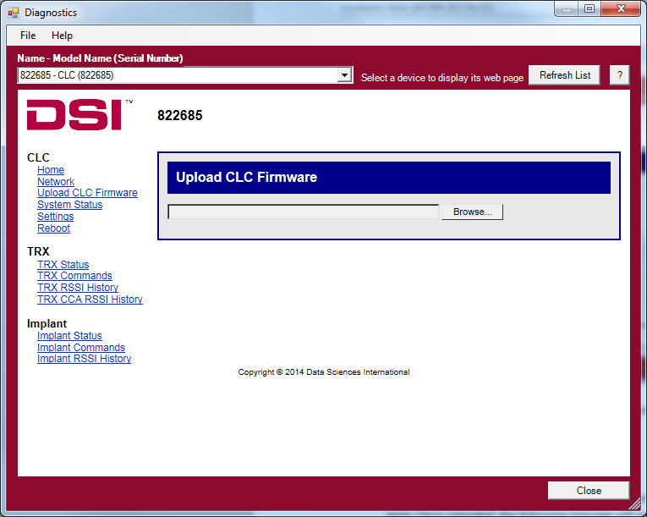
  - Select the CLC 0.1.27 file obtained during the .zip extract step above. Once uploaded, the following message will appear: Validated. Upgrade will be applied during reboot.
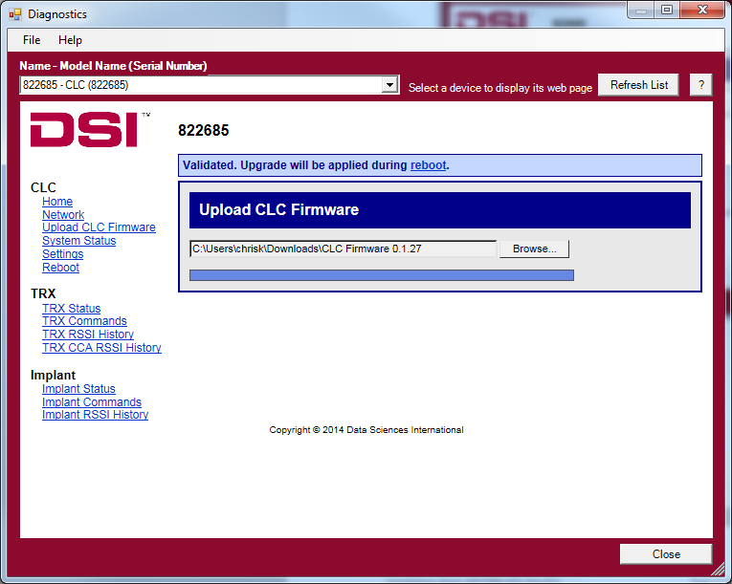
  - Select the reboot link within the message to navigate to the Reboot diagnostics page.
  - Select the Reboot button.
