Installation Notes
MX2 Firmware 1.0.11
Prior to installing, it is recommended to review the MX2 Firmware 1.0.11 Release Notes. The following are the instruction to install the firmware update.

Accessing MX2 Firmware
The website is the primary means for delivering firmware. If a CD is desired, one can be requested by contacting DSI Customer Service (CService@datasci.com).
- Navigate to www.datasci.com
- Browse to Resources | DSI Gateway Portal.
- Login using your User Name and Password. If you have forgotten or do not have a User Name and Password, the ability to request a new password or register at the site is available.
- Select Software Updates.
- Click the MX2 1.0.11.zip to download the contents to a desired location.
- Extract the files by right-clicking the .zip file and choosing Extract.

Installing MX2 Firmware
- Launch Ponemah.
- Select the Hardware | MX2 Diagnostics…
Note: If using Ponemah v5.20, select Hardware | Diagnostics…
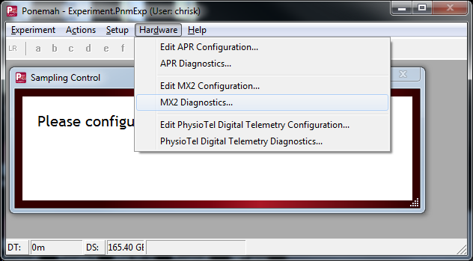

- Choose the MX2 from the Name – Model Name (Serial Number) dropdown.
Note: Select the Refresh List button if the MX2 does not appear in the dropdown list.
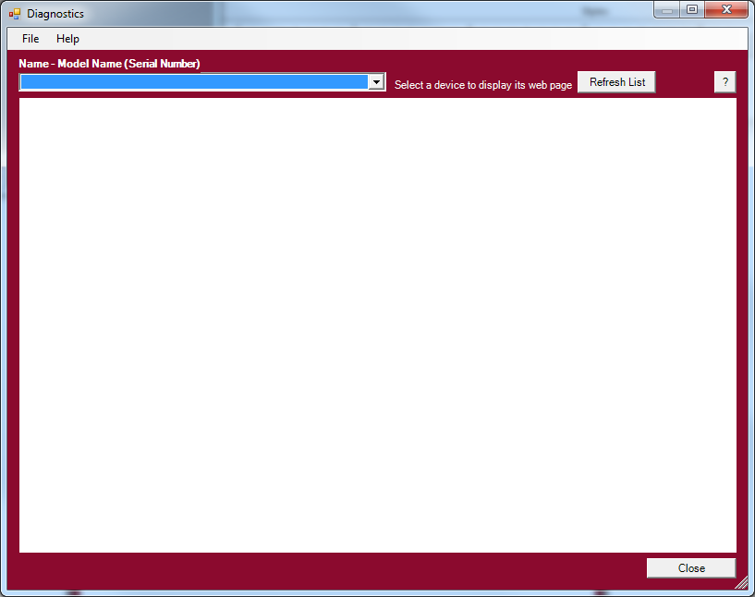
- Select the Upload MX2 Firmware page from the list view on the left side of the diagnostic page.
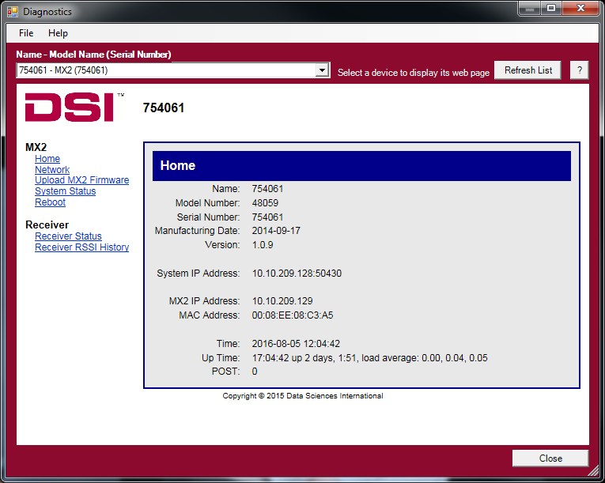
- Please complete steps a. – d. below twice.
  - Select the Browse… button.
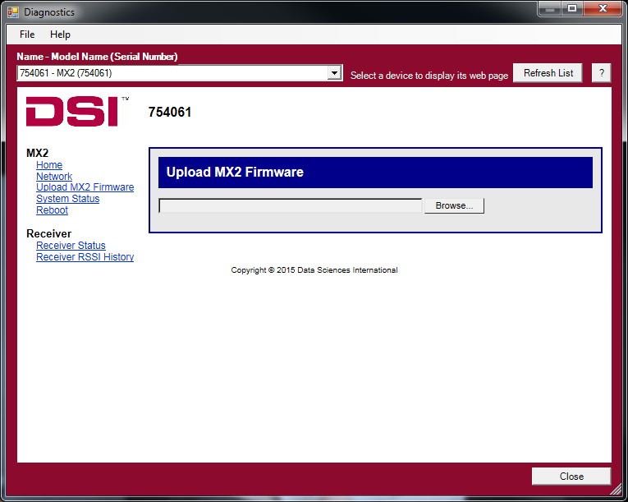
  - Select the MX2 1.0.11 file obtained during the .zip extract step above. Once uploaded, the following message will appear: Validated. Upgrade will be applied during reboot.
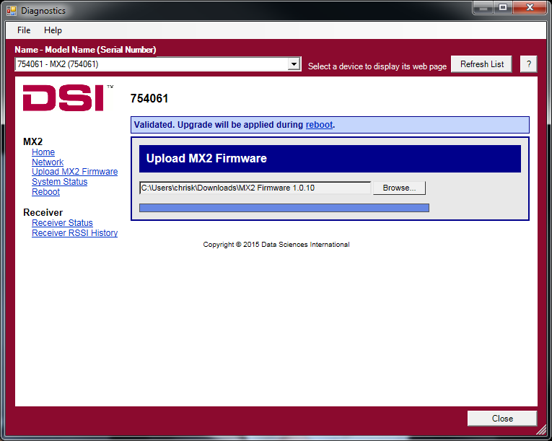
  - Select the reboot link within the message to navigate to the Reboot diagnostics page.

  - Click the Reboot button.
